# Operational Concept Description (OCD)

**MedFRS Device Diagnostic Software**

**Team 16**

|  |  |
| --- | --- |
| Misha Dowd | Project Manager |
| Delnaz Gundevia | Life Cycle Planner |
| Anfal Abdul Jaleel | System Architect |
| Nanda Kishore Kollaje Rao | System Requirements Engineer |
| Anupam Kumar | Feasibility Analyst |
| Jackie Cheng | IIV & V |

**12.09.2013**

# Version History

| Date | Author | Version | Changes made | Rationale |
| --- | --- | --- | --- | --- |
| 09/27/13 | AAJ, AK, NR | 1.0 | * Original for CSCI577a; Tailored from ICSM OCD Template; Removed Subsection 3.2: System Objectives, Constraints and Priorities; Removed Subsection 3.3: Proposed New Operational Concept; Removed Subsection 3.4: Organizational and Operational Implications; Changed sections 1: Introduction, 2: Shared Vision, 3.1: Information on Current System | * To fit CS577a course content, and remove empty sections for VCR. Add content for VCR |
| 09/27/13 | AAJ, AK | 1.1 | * Add diagrams, made cosmetic modifications | * Add content for VCR |
| 10/10/13 | AK | 2.0 | * Added System Objectives, Constraints, Priorities, Proposed New Operational Concept, Organizational and Operational Implications | * Add content for FC draft |
| 10/15/13 | AAJ | 2.1 | * Formatting | * For conformity |
| 10/16/13 | AK | 2.2 | * Modified sections 3.3 and 3.4 | * Changed business flow, capability goals * Added org and op transformations |
| 10/20/13 | AK | 2.3 | * Updated many sections | * Updates based on suggestions made in ARB |
| 12/2/13 | AK | 3.0 | * Made changes to incorporate TA comments | * Made changes to all sections the TA had advised to revise |
| 12/2/13 | AAJ | 3.1 | * Formatting | * For conformity |
| 12/9/13 | AAJ | 3.2 | * Formatting | * For conformity |

# Table of Contents

Operational Concept Description (OCD) i

Version History ii

Table of Contents iii

Table of Tables iv

Table of Figures v

1. Introduction 6

1.1. Purpose of the OCD 6

1.2. Status of the OCD 6

2. Shared Vision 7

2.1. Overview of the system 7

2.2. Benefits Chain 8

2.3. System Boundary and Environment 9

3. System Transformation 10

3.1. Information on Current System 10

3.2. System Objectives, Constraints and Priorities 12

3.3. Proposed New Operational Concept 16

3.4. Organizational and operational implications 18

# Table of Tables

Table 1 : Program Model 7

Table 2: Artifacts Table 10

Table 3: Capability Goals 12

Table 4: Level of Service Goals 13

Table 5: Relation between Current and Proposed Systems 14

# Table of Figures

Figure 1: Benefits Chain Diagram 8

Figure 2: System Boundary and Environment Diagram 9

Figure 3: Element Relationship Diagram 16

Figure 4: Proposed Business Workflow 17

### Introduction

#### Purpose of the OCD

This document provides in detail, the shared vision and goals of the stakeholders of MedFRS Project. The Success Critical Stakeholders of the project are the developers of USC, including Misha Dowd as the Project Manager, Delnaz as the Life Cycle Planner, Anfal as the System Architect, Nanda Kishore as the Requirements Engineer, Anupam as Feasibility analyst and Jackie Cheng as the IV &V and shaper. The list of Success Critical Stakeholders include Jo Ann Lane, Barry Boehm, Julia Sanchez and a small team of first responders, planners and EMTs.

#### Status of the OCD

The status of the OCD is currently at the Transition Readiness Review version number 3.2. This version is the final version we created, in it we have corrected mistakes present in previous versions.

### Shared Vision

#### Overview of the system

Table 1 : Program Model

|  |  |  |  |
| --- | --- | --- | --- |
| **Assumptions**   * Network infrastructure and cloud infrastructure are always available * Apt funding is available for the deployment of the system * EMT would use the system | | | |
| **Stakeholders** | **Initiatives** | **Value** | **Beneficiaries** |
| * Developers * Client * Volunteers * Transport Coordinators * Supervisors | * Create preliminary database management system for Volunteers/First Responders to use * Client will train volunteers and Emergency Medical Technicians on the system * Developer team will train the client on the system * Existing standard operating procedures will be modified by digitizing it (Business Process) | * Maintain order in chaotic medical situation * Expedite time for triage * Increase the number of lives saved * Empower the community to cope with disaster situations | * Victims * Volunteers * Emergency Medical Technician (EMT) * Client * Supervisors |
| **Costs**   * Development Cost * Training Cost * Hardware & Network Infrastructure cost * Device and utilities Cost (iPhone/iPad, paper barcodes) * Volunteer Medical Kit Cost | | **Benefits**   * Faster Response in state of emergency * Organized and structured approach towards helping out in times of emergency * Impart training and knowledge of emergency response procedures to volunteers * Save lives * Collect data for planning for future emergencies and improving existing operating procedures | |

#### Benefits Chain

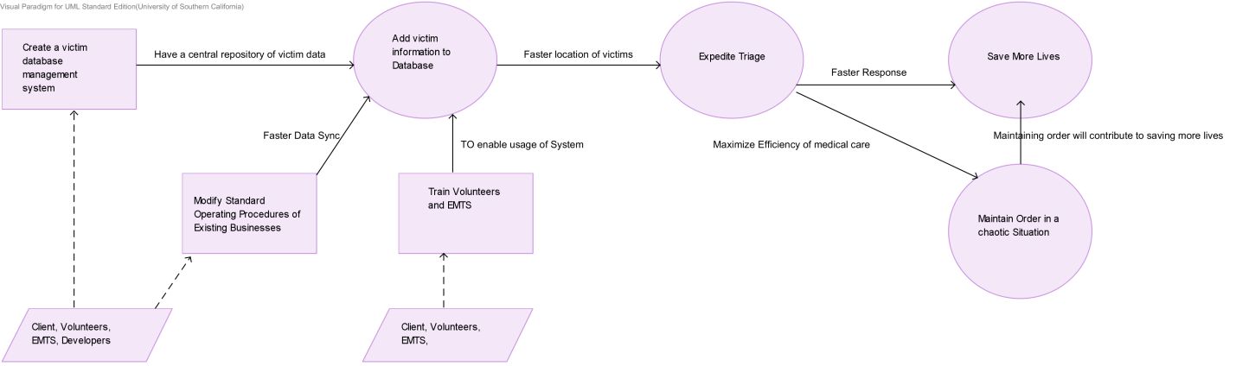

Figure 1: Benefits Chain Diagram

#### System Boundary and Environment

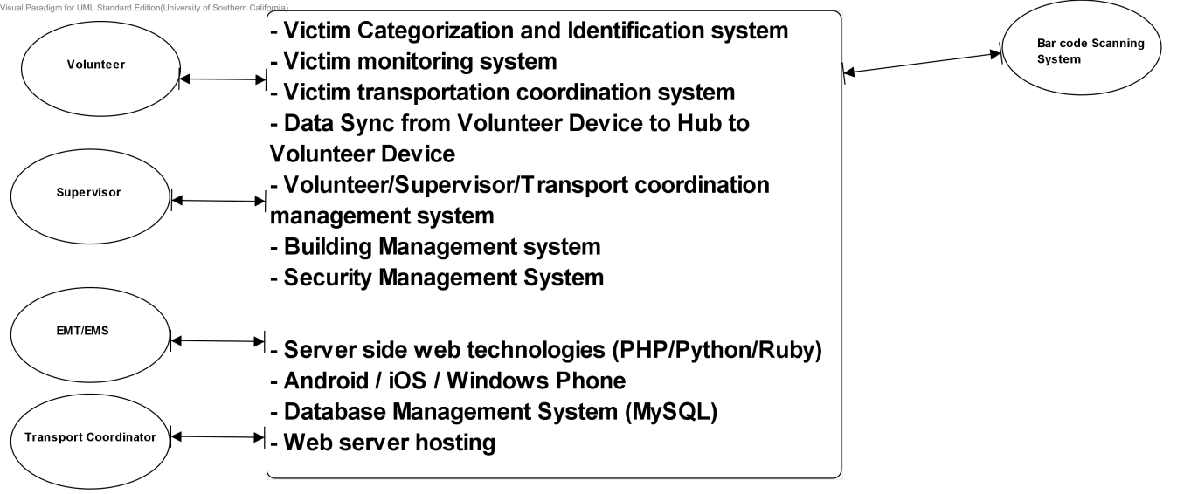Figure 2: System Boundary and Environment Diagram

### System Transformation

#### Information on Current System

##### Infrastructure

Currently, there is no software infrastructure for First Responder System. Volunteers are given kits by the supervisor, who is at a central hub. The kit includes a **pen and a paper checklist** which is a **stringed triage tag** for each victim. The medical data is left on the victim, which is the only way for EMS to retrieve it.

##### Artifacts

Table 2: Artifacts Table

|  |  |  |  |
| --- | --- | --- | --- |
| **Artifact** | **Description** | **Requested/  Received** | **Planned Delivery** |
| **IOS developer license** | **This is required in order to be able to deploy the iOS app onto an iDevice** | **Requested** | **12/05/13** |
| **Triage Tags** | **This is required by the system to create the algorithms to classify the victims** | **Received** |  |
| **iDevice** | **Device on which the app will be installed for the client** | **Requested** | **12/05/13** |
| **Server space** | **Space on which Apache server and MySQL servers will be installed** | **Requested** | **12/05/13** |
| **Triage wrist bands** | **Will be used by the volunteer to tag a victim when the system classifies him/her** | **Requested** | **12/05/13** |
| **Sample Victim’s list report** | **This Generated by the system for the EMT’s reference about where the victims are present in the disaster site.**  **Generated by the system at the supervisor’s request** | **Received** |  |

##### Current Business Workflow.

**Figure 4: Current Business Workflow**

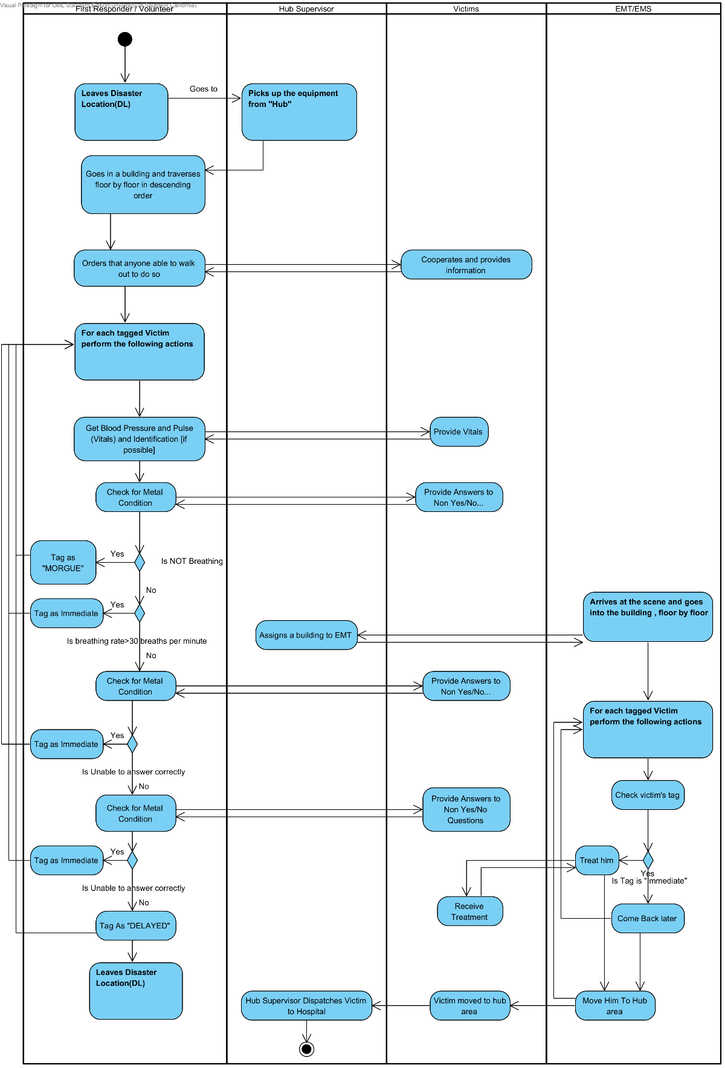

#### System Objectives, Constraints and Priorities

* + 1. Capability Goals

Table 3: Capability Goals

|  |  |
| --- | --- |
| **Capability Goals** | **Priority Level (Must Have > Should Have > Could Have > Want to have)** |
| **OC-1 Ability for volunteer to record victims condition (breathing, perfusion, mental state)** | **Must Have** |
| **OC-2 Ability for volunteer to record victims vital stats** | **Must Have** |
| **OC-3 Ability for volunteer to record victims identification information (name, age, sex, USCID, license etc)** | **Should Have** |
| **OC-4 Ability for volunteer to record victims other medical details as comment (broken bones, torn muscles, contamination etc)** | **Should Have** |
| **OC-5 Ability for system to classify victims condition automatically** | **Should Have** |
| **OC-6 Ability for the Hub Supervisor to sort victim’s list based on victim condition and building name alphabetically** | **Must Have** |
| OC-7 Ability for supervisor to assign **EMTs to buildings** | **Must Have** |
| **OC-8 Ability for Supervisor/Transport Coordinator release EMTs from buildings** | **Must Have** |
| **OC-9 Ability for Volunteer to scan barcode** | **Want to Have** |
| **OC-10 Ability for volunteer to retrieve all information about victim from system** | **Must Have** |
| **OC-11 Ability for volunteer to enter room number/floor number/other relevant location information** | **Must Have** |
| OC-12 Ability for Transport Coordinator to note victim’s transport details and destination | Must Have |

* + 1. Level of Service Goals

Table 4: Level of Service Goals

|  |  |  |
| --- | --- | --- |
| **Level of Service Goals** | **Desired** | **Accepted** |
| **OC-12 The system must account for and detect human errors during data entry** | **100% of all inputs** | **80% of all inputs** |
| **OC-13 The system must transmit data without any errors** | **100% of the time** | **100% of the time** |
| **OC-14 The system must transmit data such that only authorized persons are able to read the data** | **100% of the time** | **100% of the time** |
| **OC-15 The system should store data in device so that the data can only be readable through the app only and not directly through the filesystem** | **100% of the time** | **100% of the time** |
| **OC-16 The system must be responsive and quick(*)** | **30 milliseconds** | **1500 milliseconds** |
| **OC-17 The system must work in presence or absence of network** | **Synchronized Multi-threading (90%)** | **Basic Multi-threading (60%)** |
| **OC-18 The system could be able to interface with external devices (such as barcode scanners, printers)** | **All devices** | **Atleast major barcode scanners, provided drivers are present** |
| **OC-19 The system data must be consistently stored in a central database for concerned personnel to access or modify** | **100%** | **100%** |
| **OC-20 Ability to store victims information in absence of internet connectivity** | **10MB of data storage** | **2MB of data storage** |

**(*) Latency values are based on the empirical studies performed by students/online gamers at Stanford University**.

<http://rescomp.stanford.edu/~cheshire/rants/Latency.html>

* + 1. Organizational Goals
* **OG-1 :** Reduce the cost of search and rescue operations during disaster situation
* **OG-2 :** Maintain order in chaotic medical situation
* **OG-3 :** Expedite time for triage
* **OG-4 :** Empower the community to cope with disaster situations
* **OG-5 :** Increase the number of lives saved
  + 1. Constraints
* **CO-1: Mobile / Handheld Device:** The interface available to the volunteer/EMT must be mobile and be usable on-the-go. Therefore, the application must be developed for iOS device (iPhone/iPad) or Android.
* **CO-2 : Minimal Monetary Budget:** The cost incurred by the project supporters should be minimal and should not include anything more than, cost of printing bar-codes, testing device, organizing training, security infrastructure (security certificate) and developer license (if applicable).
* **CO-3: Security Infrastructure has to ubiquitous:** All communication has to be done if and only if a secure channel is established between the source and destination.
* **CO-4: Development Language:** Client side development must be performed on Objective-C. Web-client on Ruby on Rails/ JavaScript, Database in MySQL and server should be setup on Apache Web Server.
* **CO-5: Data Communication:** All data communication should be performed by sending/receiving well-formed JSON objects.
  + 1. Relation to Current System

Table 5: Relation between Current and Proposed Systems

|  |  |  |
| --- | --- | --- |
| **Capabilities** | **Current System** | **New System** |
| Roles and Responsibilities | **Volunteer** – Ids the victim and notes down the condition on a form, **he brings nothing back with him after his inspection**  **EMT** – Goes to a building, and searches for victims requiring immediate assistance and provides first aid  **Supervisor** – Manages and plans volunteer’s and EMT’s activities, **on site.**  **Transport Coordinator –** Manages and plans where the victims go and how on site | **Volunteer** – Ids the victim and notes down the condition on a form, **he sends back the approximate location and victim condition electronically**  **EMT** – Knows the approximate location of all immediate victims. Therefore, he goes straight to the victims location  **Supervisor** – Manages and plans volunteer’s and EMT’s activities, **remotely and electronically**  **Transport Coordinator –** Manages and plans where the victims go and how remotely and electronically |
| User Interactions | N/A | **Volunteer** enters victim data into his mobile device; accesses the victim data through his mobile device  **Supervisor** tracks the volunteers and EMT and accesses victims’ data  **Transport Coordinator t**racks where the ambulances take the victims |
| Infrastructure | No such computerized infrastructure exists | Client – Mobile Device (iOS)  Server – Apache HTTP server with PHP and Ruby installed |
| Stakeholder essentials and amenities | N/A | All electronic communication must be reliable, secure and fast |
| Future Capabilities | N/A | Ability to interface with medical sensors and medical technologies. Send data to EMT System and hospital system |

#### Proposed New Operational Concept

* + 1. Element Relationship Diagram

Figure 3: Element Relationship Diagram

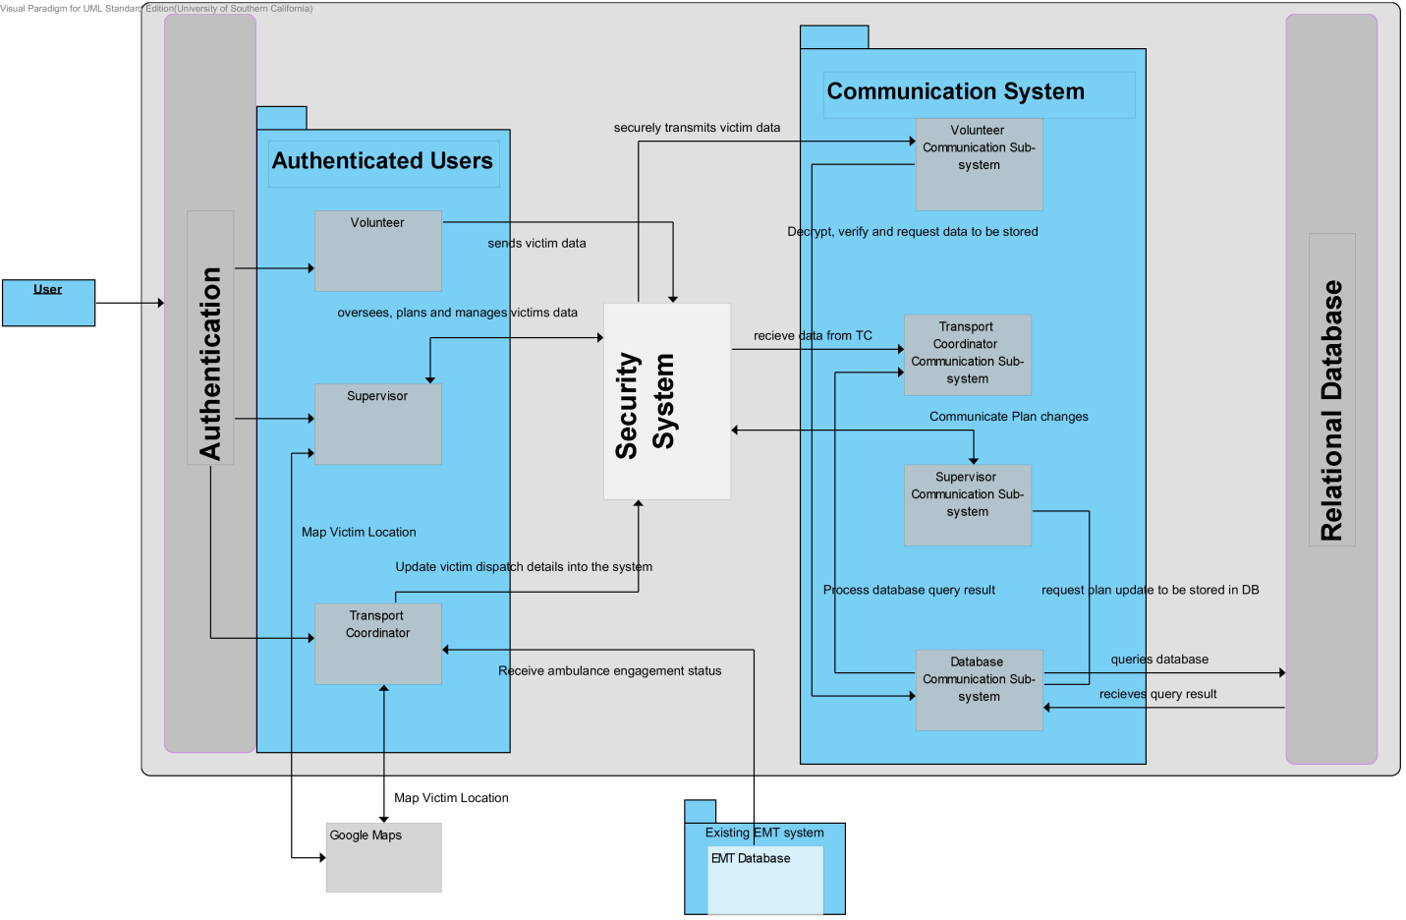

* + 1. Business Workflows

Figure 4: Proposed Business Workflow

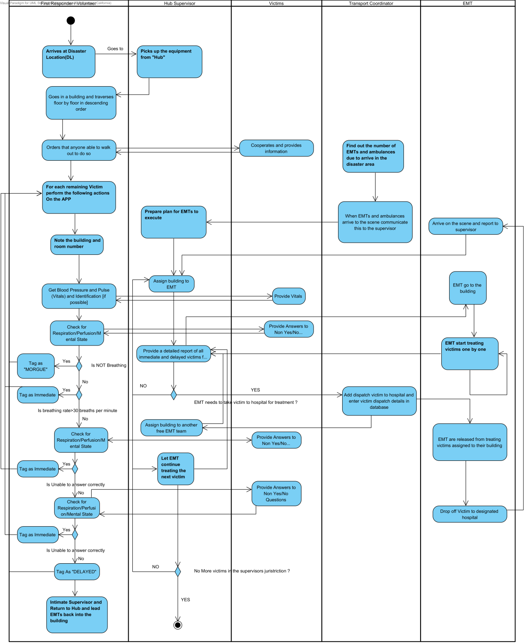

#### Organizational and operational implications

* + 1. Organizational Transformations
* System/Database admins need to be hired to maintain databases, systems
* Support specialists need to be hired in case users need help troubleshooting problems while working with the system
* Software developers/testers may be needed if any enhancements need to be made in the system in the future
* There would be no need to buy triage forms anymore because all the work previously performed by triage forms would be performed by the new system
  + 1. Operational Transformations
* Volunteers need to have apple mobile devices and have to download the app to use the system
* Supervisor, Transport Coordinators, Volunteers need to be trained to use the system effectively
* All victim information and triage categorization details would be made paperless